在过去的几年中，澳大利亚的零售市场变得越来越不可预测。此后，许多本地企业已经关闭了对公众的大门，包括Marcs，Payless Shoes，Oroton和南瓜补丁。他们的消亡通常是促使国际时尚零售商进入的原因。
一本名为“ 澳大利亚时尚的挑战 ”的杂志解释了澳大利亚零售市场的时间顺序事件，最初，“由于行业保护政策，大多数消费者仍被迫购买本地服装”。但是，当取消该政策时，市场达到了预期的目的：将场景转变为具有“具有竞争力且全球定位的行业和经济体”的市场。澳大利亚零售业的销售直线下降，许多人归咎于涌入的国际企业。
但是，有一个转折。
在澳大利亚运营了将近3年之后，全球时尚零售商Esprit宣布将退出澳大利亚的零售市场。澳新银行运营总监斯蒂芬·纽纳姆（Stephen Newnham）表示，这是一个“不幸但不可避免的决定”，执行董事汤姆斯（Thomas Tang）补充说，尽管“团队做出了巨大的努力来扭转困境，但他们最好还是专注于亚洲市场。这生意”。由于其他国际时装零售商（如GAP和Topshop）面临着澳大利亚“严峻的市场环境”的激烈竞争，这一启示不足为奇 。GAP退出了市场，而Topshop面临3500万美元的债务，进入了“自愿管理”。这使我们想知道...

澳大利亚零售市场出了什么问题？
说时装市场完全停滞不说是不正确的，因为据报道这是一个 285亿澳元的产业。这表明消费者是在服装和时尚上消费。诚然，该国的经济增长可能一直很缓慢，平均家庭债务相对较高，但澳大利亚人民仍然表现出强烈的支出增长迹象。在15年中，澳大利亚平均购买力增长了43％。显然，支出不是这里的问题，也不是这里的问题。
同样清楚的是，国际零售商的到来并没有直接打击传统零售商。尽管竞争加剧，但这些本地和国际零售商似乎都不太了解这里的市场需求。Topshop的斗争一直是当地关注的问题，因为如上所述，传统零售商的衰落一直归咎于激烈的竞争。
那么，责任应该转移到哪里呢？

也许这是一个库存问题
也许最明显的原因是从零售商的角度出发，尤其是对于国际企业而言。《悉尼先驱晨报》的一篇文章声称，澳大利亚品牌的失败是由于与世界其他地区的“脱节”。换句话说，澳大利亚人厌倦了看到不是最新趋势的服装。
Topshop Australia仅持有英国同类公司的“剩余”旧库存。这意味着运来的衣服可能已经过时了。同样，在GAP中出售的衣服是平淡而过时的。“人们想要他们想要的东西，现在就想要，而不是在六个月的时间内，”他们没有实现。假设澳大利亚人民不会注意到，这些零售商会将畅销书留在其他更先进的市场，例如美国或英国。向消费者提供他们想要的东西是至关重要的。这在很大程度上说明了为什么电子商务网站目前占据上风。

也许是电子商务
电子商务的发展比大多数传统品牌快很多，国际品牌如ASOS，Boohoo和Missguided的运行速度要快得多。澳大利亚时尚界正在慢慢追赶，其中之一就是Zara Australia。尽管这家高街零售商与Topshop的排名相同，但前者的表现要好得多。Zara的新网站于今年3月启动时，付费搜索流量增长了18900％。
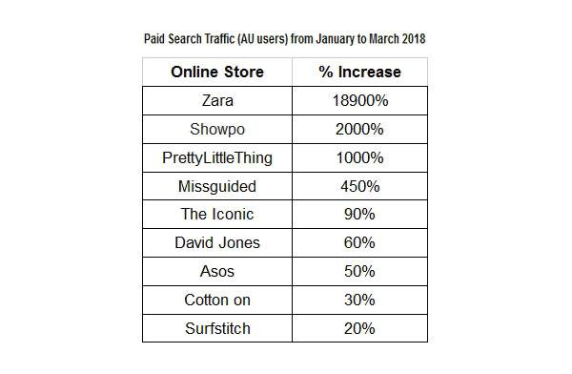
资料来源：Ragtrader

如上表所示，扎拉超越像Showpo和PrettyLittleThing品牌在2018年的第一季度高达10,000％这有助于更加网上销售一直在上升最近在近年来，超过了砖和砂浆销售更多超过零售总额增长的一半。为了正确衡量在线市场是否是决定性因素，研究澳大利亚领先的在线平台非常重要。

来了“标志性”
Iconic是该国最大的在线时装零售商之一。该平台拥有700多个品牌和45,000种产品，包括家喻户晓的品牌如Superdry，Nike和Calvin Klein。每天“产生约50,000个订单”，澳大利亚最大的时尚专业服装零售商SFG的物流总经理Alex Linton称其为“ 电子商务需求的迹象 ”。实际上，首席执行官帕特里克·施密特（Patrick Schmidt）表示，这家零售商计划在3年内达到10亿美元的销售额。但是，据Omnilytics称，不只是眼球。
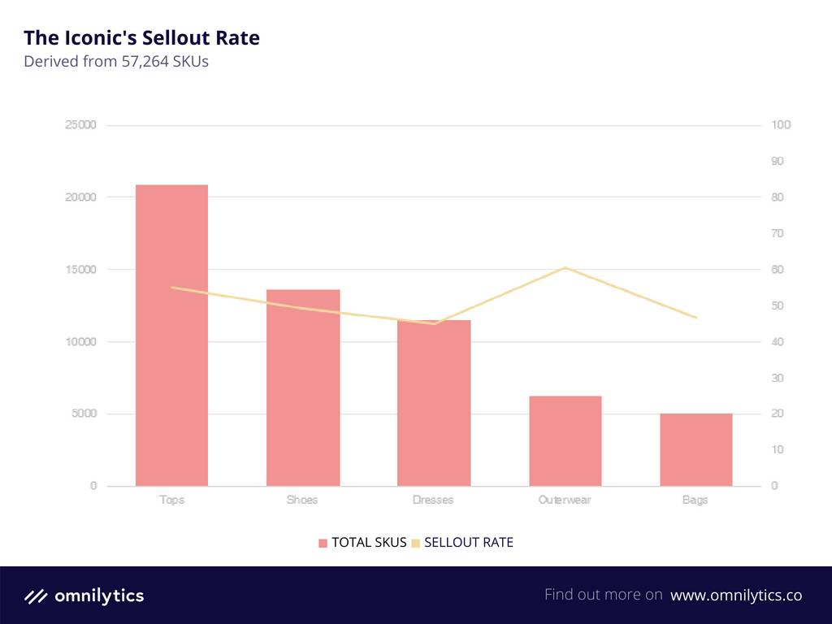

该零售商最常使用的前五名类别是按准确顺序排列的上装，鞋子，连衣裙，外套和手袋。所有售罄率都在40-60％的范围内，略高于平均水平。如小尖峰所示，外套的售罄率最高，而礼服的最少。快速浏览上图将显示，排名前五的类别的售罄情况正好接近平均基准。实际上，大多数在The Iconic中出售的品牌，例如Atmos＆Here，Amelius和Dorothy Perkins，都需要大量折扣才能实现相同或更高数量的售罄。
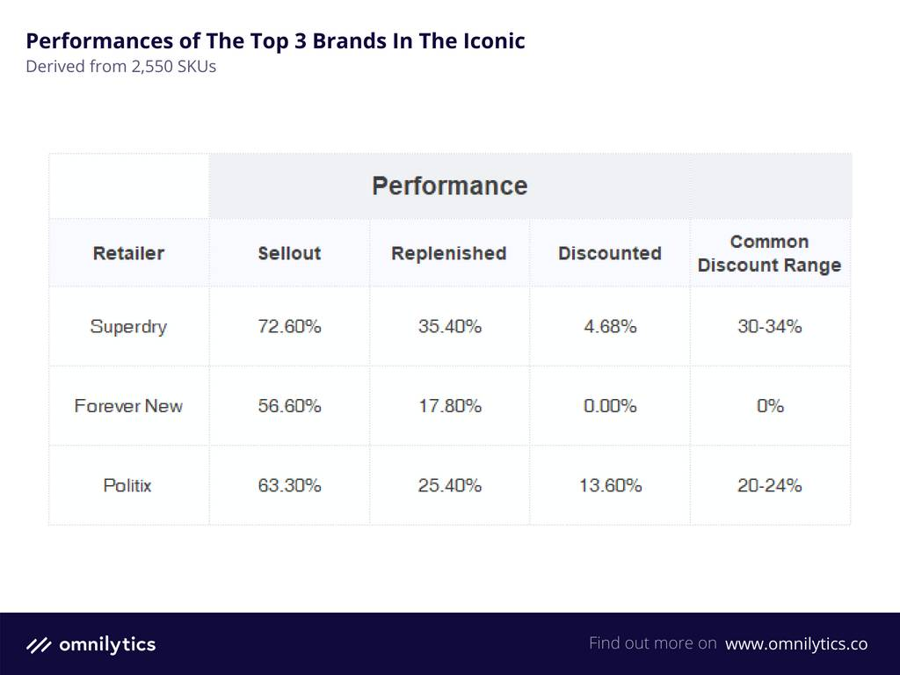

当然，某些品牌的表现更好。零售商的三个品牌，Superdry，Forever New和Politix，都看到了不错的销售率，而没有受到打折行为的很大影响。英国零售商Superdry将日式设计融入美式风格，是卖出率最高的产品，卖出率达72.6％，补货率达35.5％。此外，销售时尚单品的澳大利亚品牌Forever New在售罄一半股票的同时并未发布任何形式的折扣。澳大利亚男装品牌Politix的业绩与上述两个品牌相同。
虽然The Iconic并没有像预期中那样表现出色，但是当谈到运动服装时，这些数字告诉了一个不同的故事。最终，零售商不仅仅将自己定位为销售基本服装的在线市场，而且销售运动服的在线服装市场也有较好的表现。
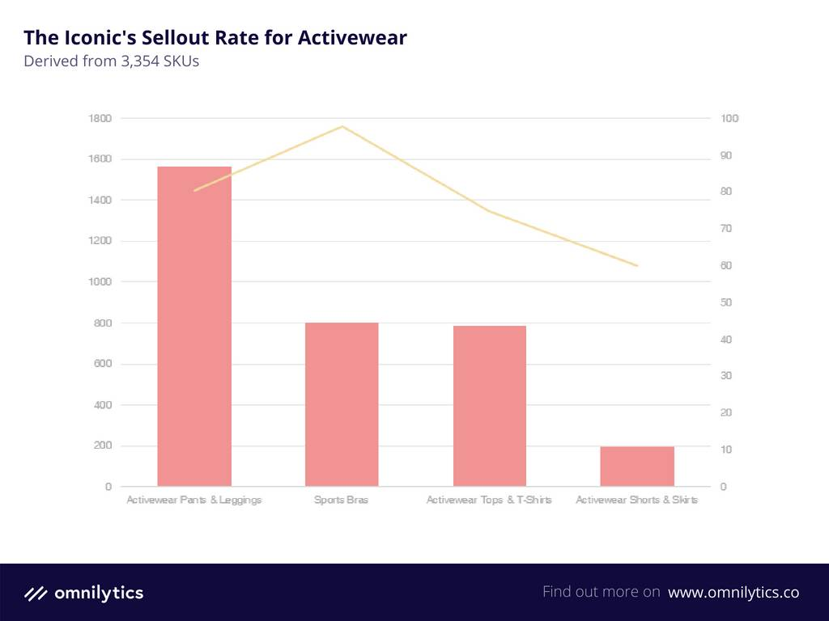

与最常使用的前五个类别相比，上面的条形图显示了显着的增长。这里的售罄范围是从55％到接近100％，运动文胸的售罄范围是97％。当然，这并不奇怪，因为The Iconic拥有耐克，洛娜·简（Lorna Jane）和阿迪达斯（Adidas）等运动服巨头。上面的数据还证明，与运动服裤子和紧身裤相比，他们的购物者更倾向于购买运动胸罩，但后者的库存更多。
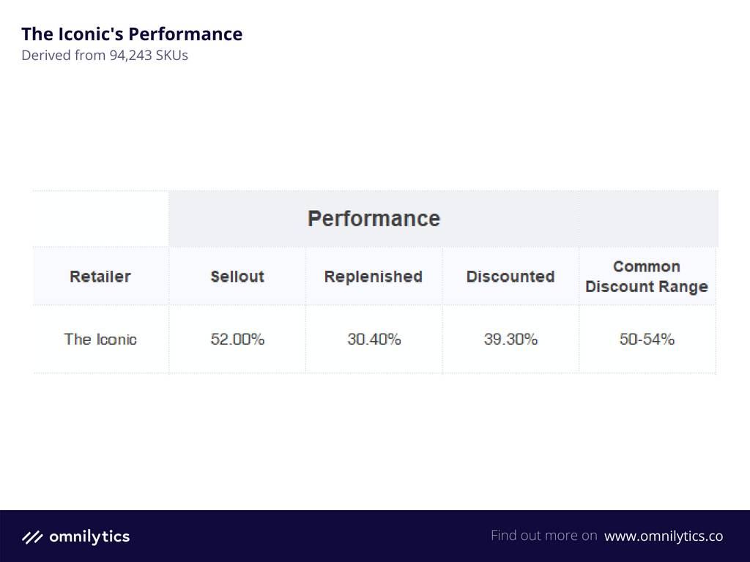

总体而言（基本服装和运动服服装），Iconic在2018年1月至4月期间释放了39.30％的折扣，大部分在50-54％的范围内。售罄情况略高，零售商售出了其总SKU的一半。
回顾以上数据后，很明显，Iconic的表现要比传统零售商好得多。但是，如果扩大规模，Iconic的性能似乎不足以导致传统零售业的衰落。上面获得的数据表明，如果更好地进行库存，在线零售商（在本例中为The Iconic）本可以获得更高的回报。购物者似乎偏爱运动服，但该类别仅占基本服装总SKU的1/4。另一方面，外套是基本服装中缺货最多的类别，但并不是最畅销的类别。

那么，有什么作用？
在这场拔河比赛中，责任似乎并没有分散，而是主要集中在澳大利亚零售商似乎不知道市场需要什么这一事实上。这里的共同主题是供应方。传统玩家没有更新他们的库存，而在线玩家也没有提供足够的消费者想要的东西。当他们继续满足需求时，Iconic可能仍在游戏中，但是如果他们滑倒，他们可能会面临与传统对手相同的命运。而且，随着亚马逊和阿里巴巴去年向澳大利亚敞开大门，在线零售商现在面临着新的竞争对手 。 除了超快的速度外，它们的另一个最大优势是，它们不会像标准零售商那样在仓库中运送库存。

“随着消费者能够在世界任何地方购物和购买，零售商必须表现出实物并适应最新和最好的'成败'食欲”
为了保持竞争力，本地和国际零售商都需要充分了解消费者的需求。Omnilytics零售总监Matthew Lovett表示，实现这一目标的关键是从更广阔的角度看待澳大利亚零售市场或任何零售环境。“时尚零售处于不断变化的状态。这是一个垂直领域，越来越受到社会媒体，技术，政治和社会变革的影响。”
消费者并不受其所生之处的影响和影响。Lovett补充说：“从AI和虚拟现实到电子商务需求，消费者不再是本地消费，而是全球消费。随着消费者能够在世界任何地方购物和购买，零售商必须表现出实物并适应最新和最好的“成败”食欲。”
仅仅因为澳大利亚人生活在世界的另一端，这并不意味着他们想错过潮流服饰。他们想要在正确的季节和正确的时间提供正确的产品。
The Australian retail market has become increasingly unpredictable over the past few years. Many local businesses have since closed their doors to the public, including Marcs, Payless Shoes, Oroton and Pumpkin Patch. Their demise was often contributed to the entrance of international fashion retailers.
A journal entitled “Challenges for Australian Fashion” explains the chronological time events of the Australian retail market, where initially, “most consumers were still obliged to buy local apparel due to industry protection policies”. However, when the policy was dismantled, the market fulfilled its intended purpose: to transform the scene into a marketplace with “competitive and globally positioned industries and economies”. Sales of the Australian retail scene plummeted, and many blamed the international players that flooded in.
But, there’s a twist.
After nearly 3 decades of operating in Australia, global fashion retailer Esprit announced that they will be withdrawing from the country’s retail market. Director of ANZ operations Stephen Newnham stated that it was an “unfortunate but unavoidable decision”, with Executive Director Thomas Tang adding that it was best for them to focus on Asian markets, even though there were “intensive efforts made by the team to turn around the business”. This revelation came as no surprise, as other international fashion retailers such as GAP and Topshop faced the heat of Australia’s “harsh market condition”. GAP pulled out of the market, while Topshop faced a $35 million debt, entering a “voluntary administration”. This leads us to wonder…

What Went Wrong With The Australian Retail Market?
To say that the fashion market is completely stagnant here is not true, as it is reportedly an AUD 28.5 billion dollar industry. This indicates that consumers ARE spending on apparels & fashion. Granted, the country’s economic growth may have been slow, and an average household debt is relatively high, but the people of Australia still showed strong symptoms of growth in spending. In 15 years, the purchasing power of the average Australian saw a 43% growth. Clearly, expenditures weren’t, and aren’t, the issues here.
It is also clear that the arrival of international retailers was not a direct hit on traditional retailers. While there was increased competition, it seemed that both of these local and international retailers couldn’t quite grasp the market demands here. The struggle of Topshop has been a concern for the local scene because as mentioned above, the fall of traditional retailers has always been blamed on tough competition.
So, where did the blame shift to?

Maybe It’s A Stocking Issue
Perhaps the most obvious reason is from the retailer’s end, especially for international players. An article by Sydney Morning Herald claimed that the failure of brands in Australia was because of a ‘disconnection’ with other parts of the world. In other words, Australians are tired of seeing clothing that are not of the latest trends.
Topshop Australia only carried old stocks that were ‘leftovers’ from its British counterpart. This means the clothes that were shipped across could be a season old. Similarly, the clothing sold in GAP were bland and old-fashioned. “People want what they want and they want it now, not in six months’ time,” and they did not deliver. These retailers kept the bestsellers to other more advanced markets, like the USA or UK, assuming that the people of Australia would not notice. Giving consumers what they want, when they want it, is extremely crucial. This goes a long way to suggest why e-commerce sites currently have the upper hand.

Or Maybe It’s E-Commerce
E-commerce moves a lot faster than most traditional brands, with international brands like ASOS, Boohoo and Missguided running at a much faster pace. The Australian fashion sector is slowly catching up, and one of them is Zara Australia. While this high-street retailer is on the same rank as Topshop, the former fared much better. When Zara’s new website launched in March this year, it saw a 18900% increase in paid search traffic.
Source: Ragtrader

As depicted in the table above, Zara surpassed brands like Showpo and PrettyLittleThing by a whopping 10,000% in Q1 of 2018. It helps even more that online sales have been on a rise lately in recent years, outstripping brick-and-mortar sales by more than half of total retail sales growth. To properly gauge if the online market is a determining factor, it’s important to study the leading online platform in Australia.

In Comes ‘The Iconic’
The Iconic is one of the largest online fashion retailers in the country. The platform carries more than 700 brands and 45,000 products, including household names like Superdry, Nike and Calvin Klein. It “generates around 50,000 orders” on a daily basis, which Alex Linton, logistics general manager of SFG – the largest fashion speciality apparel retailer in Australasia – called “a sign of e-commerce demand”. In fact, Chief Executive Patrick Schmidt said that the retailer is set to reach sales of $1 billion in 3 years. According to Omnilytics, however, there’s more than meets the eye.

The top five most available categories for this retailer were tops, shoes, dresses, outerwear and bags, in that exact order. All sellout rates were between the ranges of 40-60%, which is somewhat above average. Outerwear – as shown in the small spike – received the highest sellout rate, while dresses had the least. A quick glance on the image above will show that the sellouts for the top five categories were just around the average benchmark. In fact, most brands sold in The Iconic, such as Atmos & Here, Amelius and Dorothy Perkins, needed a fair amount of discounts to achieve the same or higher number of sellouts.

Of course, some brands fared better. Three brands from the retailer, Superdry, Forever New and Politix, saw a decent amount of sellout rates without much influence from discounting practices. Superdry, a British retailer that infuses Americana style with Japanese designs, saw the best sellout amongst all, with a 72.6% sellout and a 35.5% replenishment rate. Additionally, Forever New, an Australian brand that sells trendy pieces, sold out half of its stock without releasing any form of discounts. Politix, a menswear brand in Australia, mirrored the two brands above in performance.
While The Iconic does not come across as a retailer that is performing as expected, the numbers told a different story when it comes to athletics apparels. Ultimately, the retailer does not market itself as just an online marketplace that sells basic apparels, but also sportswear, which saw better numbers.

The bar chart above shows a significant rise, in comparison with the top five most available categories. The sellout range here is from 55% to a near 100%, with sports bras seeing a 97% sellout. Of course, this may not come as a surprise, since The Iconic features sportswear powerhouses like Nike, Lorna Jane and Adidas. The data above also proves that their shoppers are more inclined to buy sports bras than activewear pants & leggings, but the latter were stocked at a higher number.

Overall (basic apparel and sportswear apparel), The Iconic released 39.30% of discounts for the period of January to April of 2018, mostly within the range of 50-54%. The sellouts were slightly higher, with the retailer selling out half of its total SKUs.
After reviewing the data above, it is evident that The Iconic is doing much better than traditional retailers. However, if put on a larger scale, the performance of The Iconic doesn’t seem to be enough of a cause for the traditional retail’s downfall. The data obtained above pointed towards the fact that online retailers – in this case, The Iconic – could have seen higher returns if stocking was conducted better. Shoppers seemed to favour activewear, but the category only had ¼ of total SKUs for basic apparels. On the other hand, outerwear was the most out-of-stock category for basic apparels, but it wasn’t the most available.

So, What Gives?
In this tug-of-war scenario, the blame doesn’t seem to be equally dispersed but focused mainly on the fact that Australian retailers don’t seem to know what the market wants. The common theme here is the supply side. While traditional players did not update their inventories, the online players also did not supply enough of what consumers wanted. The Iconic may still be in the game as they continue to supply the demand, but if they slip, they may face the same fate as their traditional counterparts. What’s more is that online retailers now face new competitors, as Amazon and Alibaba have opened their doors to Australia last year. Besides their ultra-fast speed, another one of their biggest advantages is that they don’t carry stocks in a warehouse-like standard retailers do.

“With consumers being able to shop and buy from anywhere in the world, it is imperative that retailers behave in-kind and accommodate that ‘make or break’ appetite for the newest and the best”
In order for them to stay competitive, both local and international retailers need to fully understand what consumers are looking for. Matthew Lovett, Director of Retail in Omnilytics, stated that the key to this is to look at the Australian retail market, or any retail scene, from a wider perspective. “Fashion retailing is in a state of flux. This is a vertical that has become increasingly subject to movements in social media, technology, political and social change.”
Consumers are not rooted and influenced by just where they are from. Lovett adds that “from AI and virtual reality to e-commerce demand, consumers are no longer consuming locally, but globally. With consumers being able to shop and buy from anywhere in the world, it is imperative that retailers behave in-kind and accommodate that ‘make or break’ appetite for the newest and the best.”
Just because Australians live on the other side of the world, that doesn’t mean they want to miss out on trending apparels. They want the right product, in the right season and at the right time.

